Assignment 4

In round k an offer S is played by X if K is even or 0 and by Y if K is uneven
$S_{k}∈[0,101-k]$ being the payoff that player X gets and player Y getting $101-k-S$
We solve using backwards induction in round 100 there is no more to be shared thus both players get 0 if we rach round 100

Here is the drawing
(notice ive swapped the notation because I found it confusing)
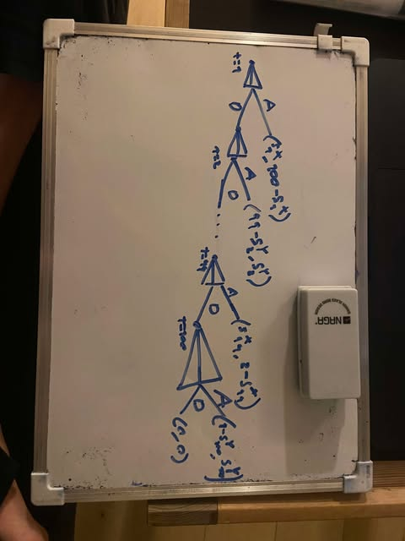

We reason subgame nash equalibria
In round 100 if $S≥0$ then X accepts thus $S_{99}=0$ where Y gets 1
thus in round 99 Y accepts if he gets more than $≥1$ giving us $S_{98}=1$

we can write it a little more compact
$$100:\left(s_{100}^{X},s_{100}^{Y}\right)=(0,1)$$
$$99:\left(s_{99}^{X},s_{99}^{Y}\right)=\left(1,1\right)$$
$$98:\left(s_{98}^{X},s_{98}^{Y}\right)=(1,2)$$
These are all unique subgame EQ’s
we note that a player will accept the amount of turns he has remaining leaving the restfor himself
This gives us the only subgame perfect EQ strategies
$$SPEQ:\{offer counterparty his \# of remaining turns and take the rest;-||-\}$$
Ending in emidiate resolution
$$1:\left(s_{1}^{X},s_{1}^{Y}\right)=(50,50)$$

